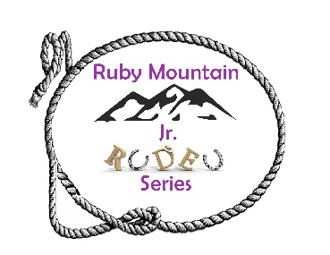
Donation Items

Please see the following list of prizes we are seeking sponsors for. If you would like to donate a prize or put your donation toward a certain prize, please mark the box.
Prize | Cost | Donation
1st Place All Around -- Saddle (6 needed) | $1000 each | All Saddles are  Sponsored for 2026
2nd Place All Around Prize (6 needed) | $400 each
3rd Place All Around Prize (6 needed) | $300 each
4th Place All Around Prize (6 needed) | $150 each
5th Place All Around Prize (6 needed) | $100 each
1st Place Event Buckle (28 needed) | $150 each
2nd Place Event Prize (28 needed) | $100 each
3rd Place Event Prize (28 needed) | $75 each
Other (Contestant Gifts, “Little Trotter” (most improved) )

Your support is greatly appreciated!

Checks can be made payable to RMJR (Ruby Mtn Jr. Rodeo Series) FEIN: 93-3122556
Please send donations to:
PO Box 8358
Spring Creek, NV 89815

